EXPERIMENT 9

Jai Prasadh

PHY 115L

INTRODUCTION

In this experiment I sought to learn about the interfering and diffractive effects of the wave nature of light. Using a carefully aligned apparatus, I desired to measure the width of a laser beam. I then set out to quantitatively analyze various kinds of interference, namely those coming from a set of double slits, a single slit, and a set of multiple slits, all at varying slit widths and spacings. In analyzing these phenomena, I aimed to investigate the enveloping behavior of the single slit diffraction and to compare the observed heights and arrangement of peaks and fringes to the theoretical expectations. Finally, I sought to observe and measure the Airy Disc, which is an important quantity in optics, limiting the resolution of optical instruments.

RESULTS

Measurement of Laser Beam Width:

In this section, I set up the specially-aligned Pasco apparatus and used it to measure the width of the laser beam at the light sensor at the other end of the apparatus. I did this by sweeping the sensor across the laser beam using the rack-and-pinion setup and measuring the intensity signal response at each position. I determined the width of the laser as observed by the sensor to be $0.13±0.01cm$ where I define width as the full width at half maximum (FWHM) of the intensity response peak. I will use this FWHM convention for peak width throughout this report unless otherwise noted.

Double Slit Interference:

I began by observing double slit interference using a pair of slits 0.08mm thick spaced 0.50mm apart. Figure 1 shows the interference pattern for this double slit setup.

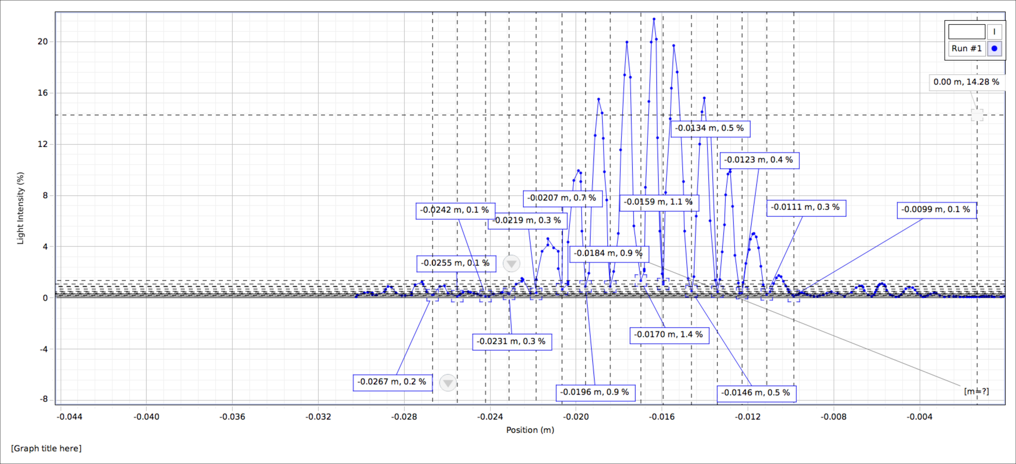

Figure 1

I measured the spacing between dark fringes in the interference pattern to be $0.12±0.01cm$ and the distance from the laser to the sensor was $0.99±0.03m$, from which I determined the wavelength of the laser to be $626±60nm$. This value agrees with the reported laser wavelength of $650nm$, but due to the large uncertainty on the calculated wavelength stemming from the relatively noisy measurement of fringe spacing, I used the reported wavelength in the remainder of the analysis for this experiment.

I then observed the interference pattern for 3 other double slit setups. Figure 2 shows the pattern for one of these, specifically the one with slit width of 0.04mm and spacing of 0.25mm.

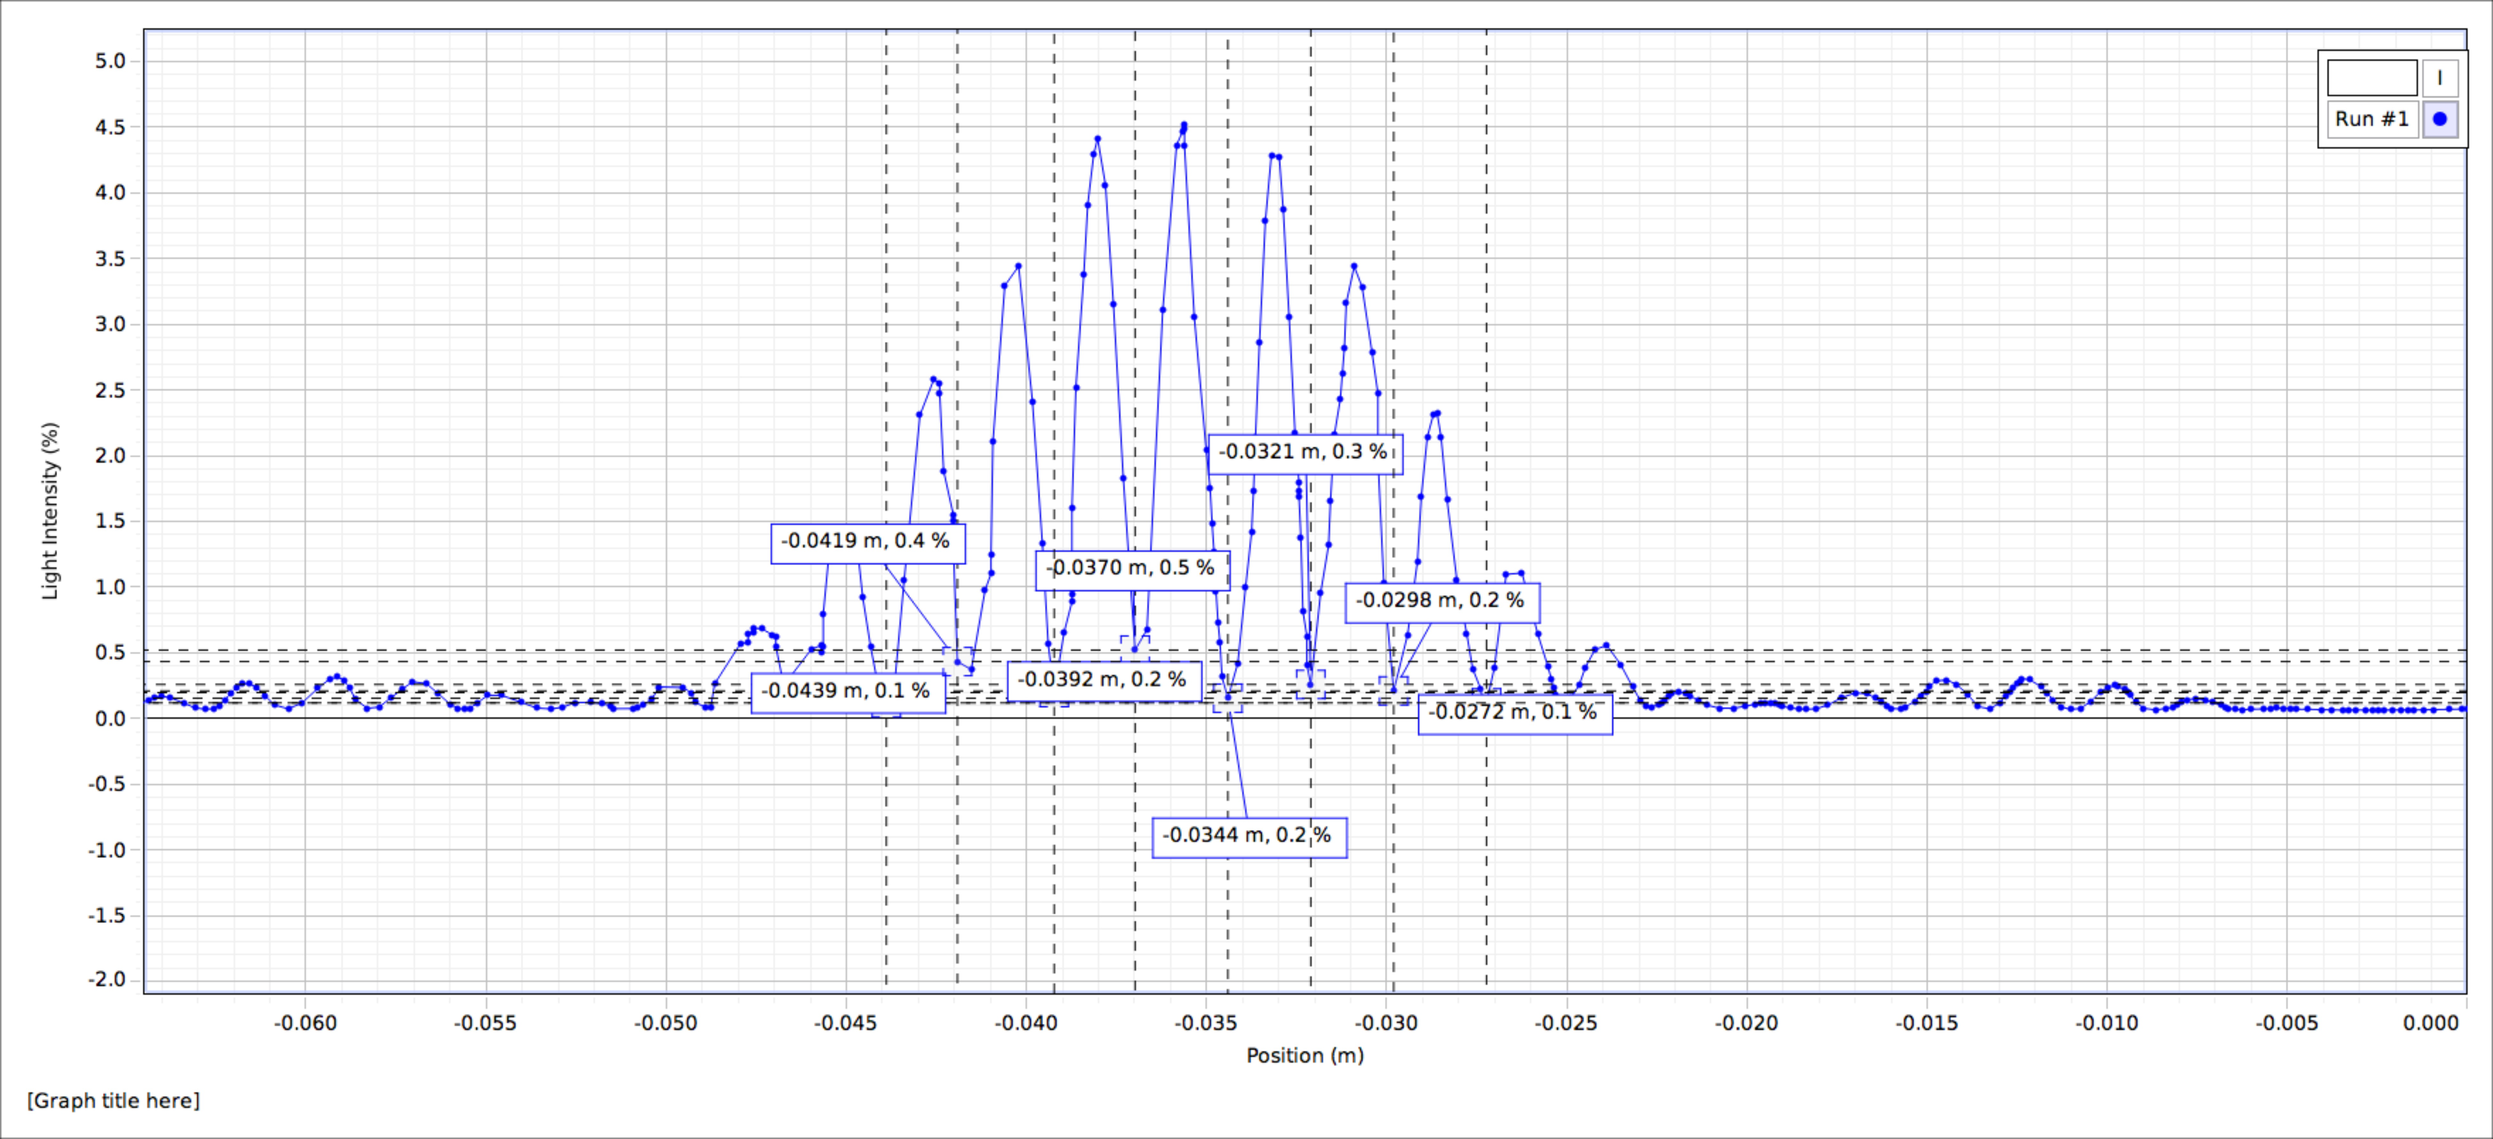

Figure 2

At each of these double slit setups, I measured the dark fringe spacing and compared what I observed to the theoretical predictions. My results are as follow.

Table 1

|  |  |  |  |  |
| --- | --- | --- | --- | --- |
| Slit width, spacing (mm) | Observed fringe spacing (cm) | | Predicted fringe spacing (cm) | |
| 0.08, 0.50 | 0.12 | 0.01 | 0.13 | 0.01 |
| 0.08, 0.25 | 0.24 | 0.03 | 0.26 | 0.01 |
| 0.04, 0.50 | 0.11 | 0.01 | 0.13 | 0.01 |
| 0.04, 0.25 | 0.24 | 0.02 | 0.26 | 0.01 |

The theory holds up since my observations were within experimental uncertainty of the predictions.

Single Slit Diffraction:

In this section, I started by studying a single slit of width 0.08mm at 0.99m to the light sensor. Figure 3 shows the interference pattern observed from this setup.

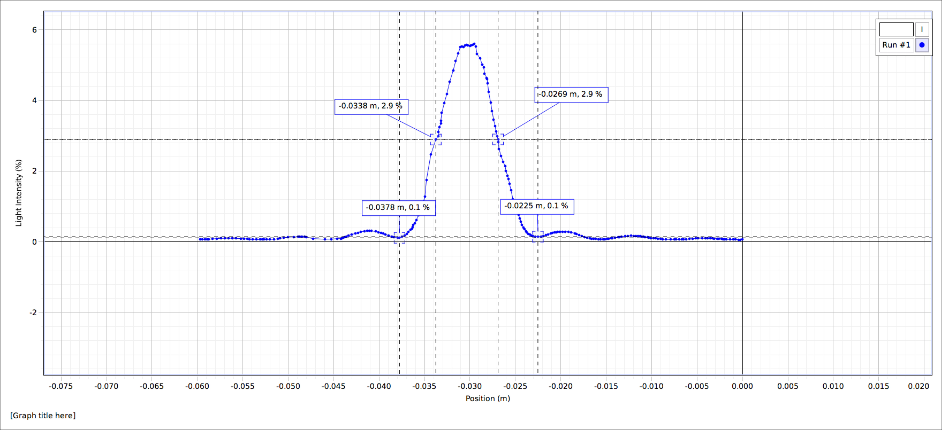

Figure 3

This intensity recorded at various positions resembles the familiar sinc-function I expected from the theory of diffraction. The width of this central peak (FWHM) was measured to be $0.7±0.1cm$, which is exactly on the theoretical prediction of $0.70±0.02cm$, further validating the model used to study wave diffraction. The central peak is much wider than the laser beam width measured earlier ($0.13±0.01cm)$, due to the broadening of the beam as governed by Huygens’s Principle since only part of the initial plane wave passes through the slit. Additionally, the observed angular spread of the beam was $0.007±0.001 rad$, within experimental uncertainty of the predicted $0.008 rad$ coming from the relation $\frac{λ}{b}$ for $λ=650nm$ and slit width $b=0.08mm$.

I then switched the apparatus to single slit setups with slit widths of 0.02mm, 0.04mm, and 0.16mm. Figures 4 and 5 show the observed intensity pattern for two of these trials, at slit widths 0.02mm and 0.16mm, respectively.

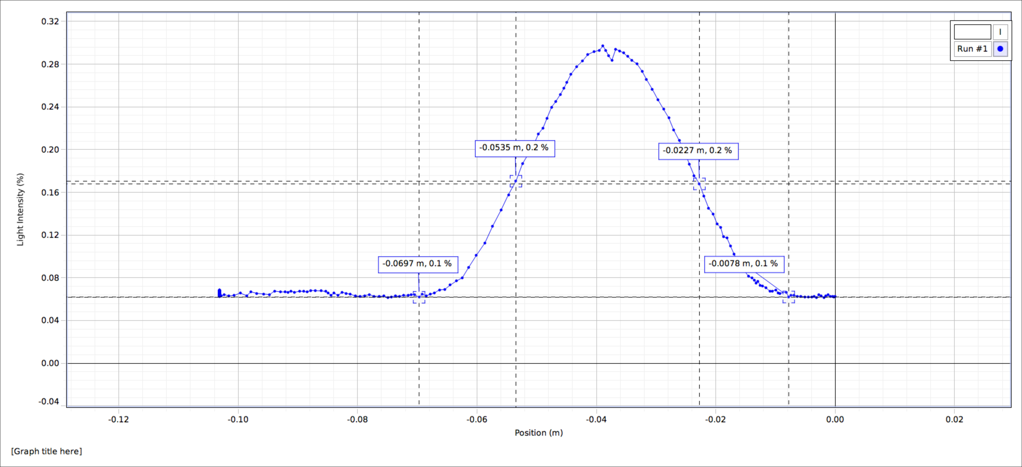

Figure 4

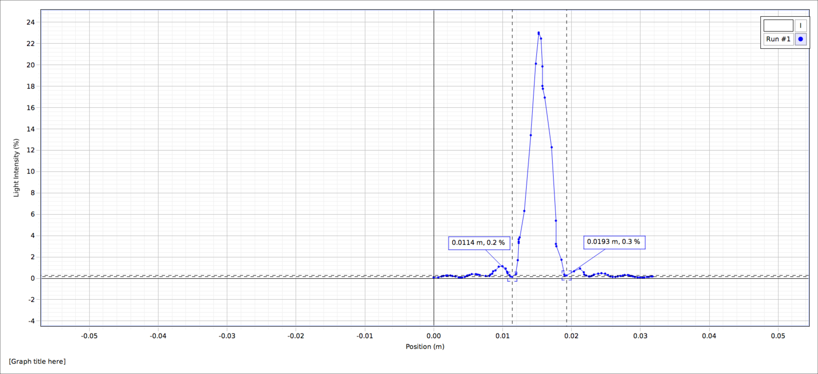

Figure 5

From these recordings of the intensity versus position at various slit widths, it is apparent that the width of the slit and the width of the principal peak have an inverse relation. Also, the non-principal peaks become more and more pronounced with a wider slit and are almost imperceptible at slit width 0.02mm. I sought to quantitatively assess this relation by measuring the central peak width (FWHM) for each of the single slit patterns and compare that value to the predicted width to test the theory. My results are as follow.

Table 2

|  |  |  |  |  |  |  |  |  |
| --- | --- | --- | --- | --- | --- | --- | --- | --- |
| Slit width (mm) | 0.02 | | 0.04 | | 0.08 | | 0.16 | |
| Observed central peak width (cm) | 3.0 | 0.5 | 1.5 | 0.5 | 0.7 | 0.1 | 0.3 | 0.1 |
| Predicted central peak width (cm) | 2.8 | 0.1 | 1.39 | 0.04 | 0.70 | 0.02 | 0.35 | 0.01 |

Measuring the principal peak widths was a little bit noisy, but the predictions served well and were quite accurate.

Next, I fitted the known $I\left(x\right)=sinc^{2}(p[x-q])$ function to the measurements obtained via Capstone. This initial fit estimated the horizontal translation constant at $q=-3.023±0.001cm$, which I used to adjust all the data to be centered at $x=0$ to facilitate the comparison of various plots superimposed on each other. Figure 6 shows this adjusted data against the fitted function for intensity.



$$I\left(x\right)=a {Sinc}^{2}(px)$$

$$\begin{matrix} & Estimate & Standard Error \\ a & 5.63 & 0.02 \\ p & 398 & 1\end{matrix}$$

Figure 6

The resemblance of the sinc-function to the observed data points confirms the theory behind single slit diffraction. Furthermore, the fitted value for the parameter $p=398±1 rad/m$ agrees within error bounds of the predicted parameter value of $390±10 rad/m$.

To analyze the envelope behavior of the single slit pattern on the double slit pattern, I superimposed the data for both the single slit and double slit trials at slit width 0.08mm (0.50mm spacing in the double slit trial) onto a graph of the fitted sinc-function. To accomplish this, I had to adjust the double slit raw data to be centered at zero and lower the intensities such that they were on the same scale as the single slit trial. Figures 7 and 8 show the overlaid double slit trial at a broader and close-up scale, respectively.



Figure 7





Figure 8

This overlaid plot confirms my expectation that the single slit diffraction pattern envelopes the more complicated double slit interference pattern, validating the theory I had learned. More explicitly, the wider scale envelope of the intensity in the double slit pattern is determined by the intensity pattern for a single slit.

Multiple Slit Interference:

In this portion of the experiment, I turned my attention to diffraction resulting from N slits, for $N∈\left\{2,3,4,5\right\}$, slit width 0.04mm and spacing 0.125mm. For the two-slit case, I observed the familiar double slit pattern and that for 3, 4, and 5 slits, I was able to observe secondary peaks in between the more prominent primary ones. All the patterns I observed were enveloped by the diffraction pattern for a single slit of width 0.04mm. Figures 9 and 10 show the interference pattern for 3 and 5 slits, respectively.

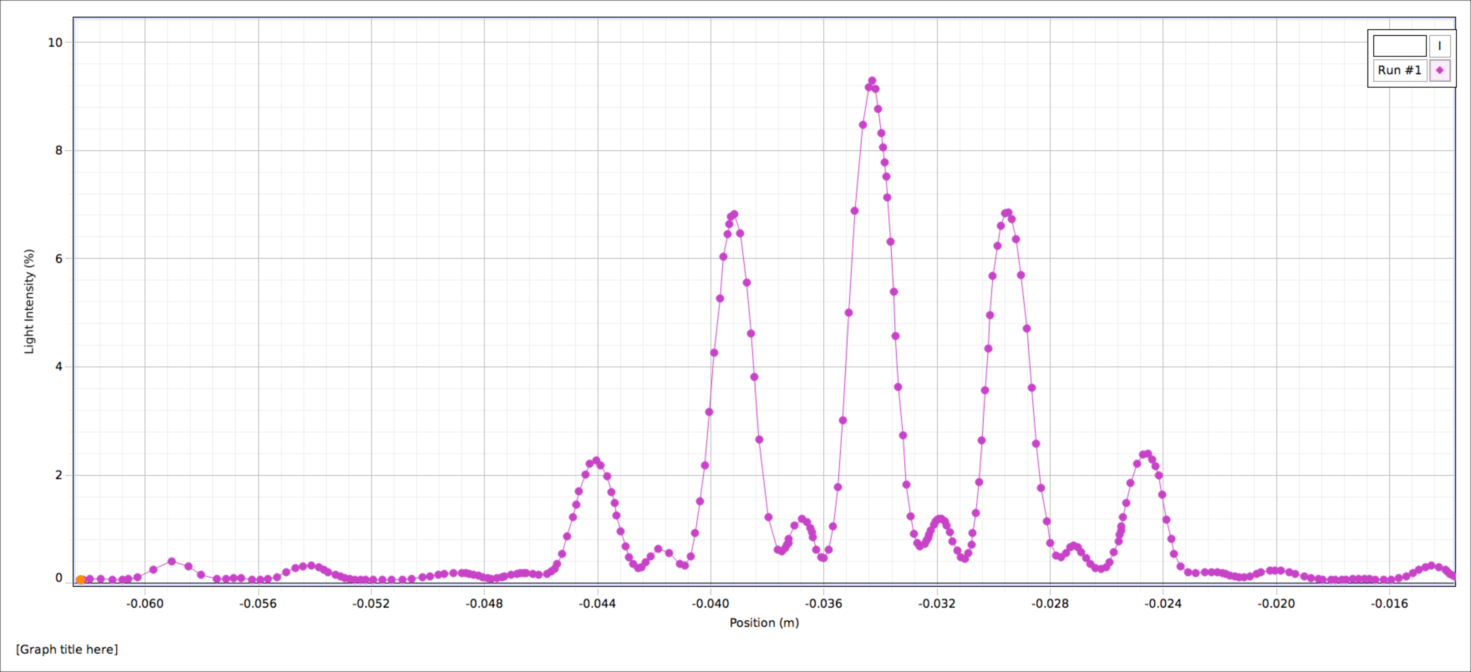

Figure 9

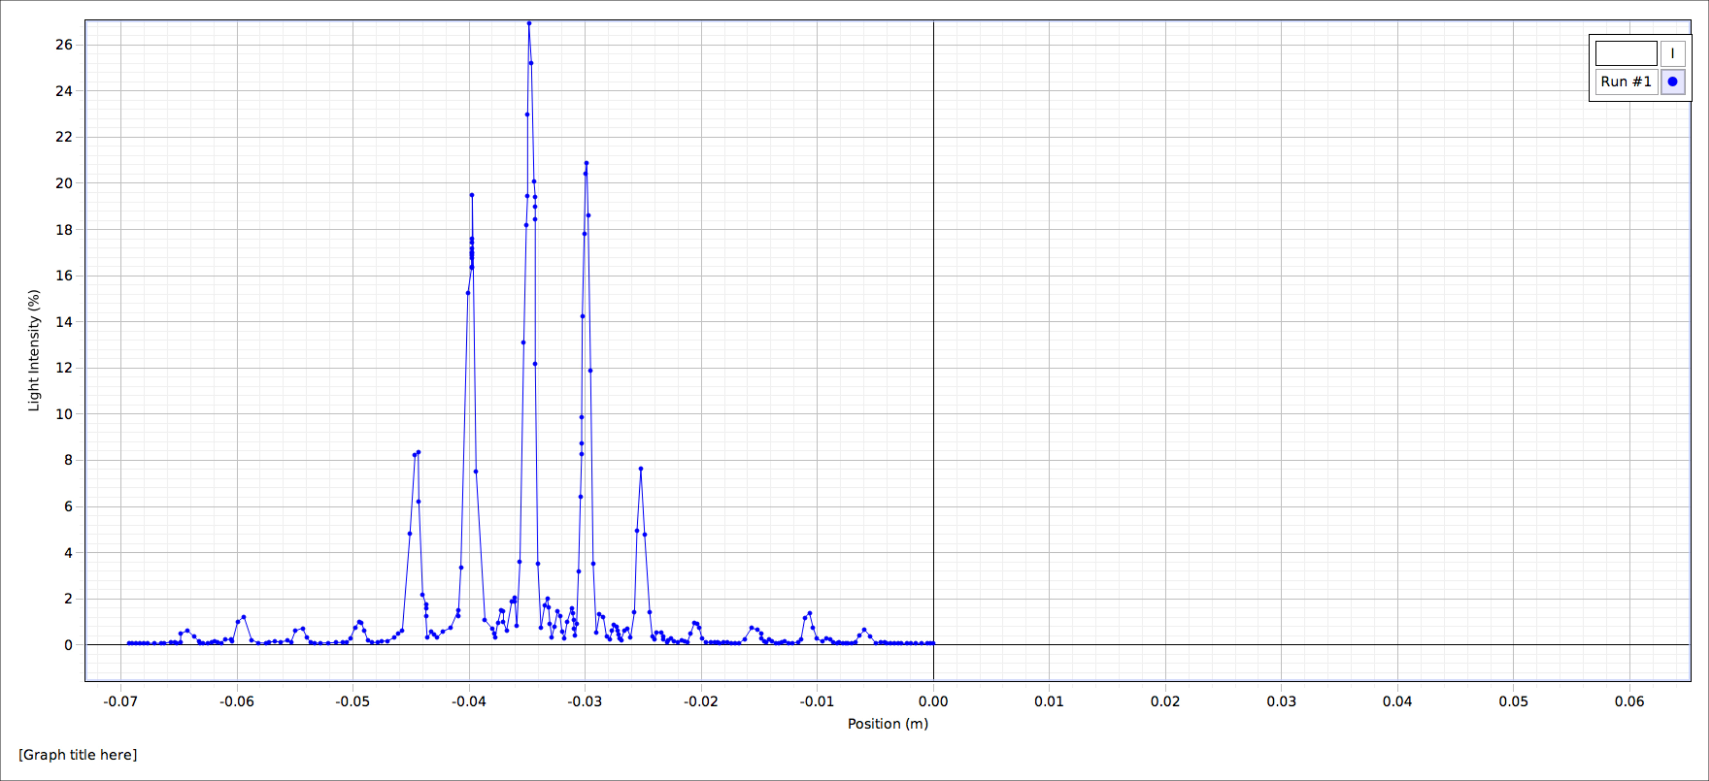

Figure 10

It is qualitatively apparent that the secondary peaks decline in size as N increases. Next, I measured the diffraction angle of the first- (1°) and second-order (2°) primary peaks for each N and compared those to the predicted values. My results are shown in table 3.

Table 3

|  |  |  |  |  |  |  |  |  |
| --- | --- | --- | --- | --- | --- | --- | --- | --- |
| N | 2 | | 3 | | 4 | | 5 | |
| Observed 1° angle (rad) | 0.0053 | 0.0002 | 0.0051 | 0.0002 | 0.0051 | 0.0002 | 0.0051 | 0.0002 |
| Predicted 1° angle (rad) | 0.0052 |  | 0.0052 |  | 0.0052 |  | 0.0052 |  |
| Observed 2° angle (rad) | 0.0106 | 0.0003 | 0.0104 | 0.0003 | 0.0101 | 0.0003 | 0.0101 | 0.0003 |
| Predicted 2° angle (rad) | 0.0104 |  | 0.0104 |  | 0.0104 |  | 0.0104 |  |

These observations were within experimental uncertainty of the predictions, indicating a strong theoretical basis once more. I subsequently assessed the relation between the secondary peak and the principal primary peak by measuring the ratio of their heights at each setup of N slits.

For N=2, no secondary peaks were visible, which makes sense given this was just the double slit experiment. For N=3, I determined the ratio of secondary maxima to the principal peak was $0.125±0.001$. For N=4, I found this ratio to be $0.088±0.001$, significantly lower. At N=5, I measured the ratio as $0.083±0.001$, smaller still. The ratio of secondary to principal peak height drops by about 15-20% when N increases by 1, though this relation does not seem to be linear.

Finally, I measured the width (FWHM) of the first-order (1°) peaks at each N by taking the average of the widths of the -1 and +1 peaks. Table 4 shows these measurements.

Table 4

|  |  |  |  |
| --- | --- | --- | --- |
| N | Average 1° Peak Width (cm) | | Predicted 1° Peak Width (cm) |
| 2 | 0.26 | 0.04 | 0.23 |
| 3 | 0.17 | 0.01 | 0.15 |
| 4 | 0.14 | 0.02 | 0.11 |
| 5 | 0.091 | 0.005 | 0.092 |

I also plotted these observations against the known first-order peak widths, given by the discrete function of N as approximately $\frac{2.8λL}{πNd}$. Figure 11 shows this plot for N=1 to N=10.

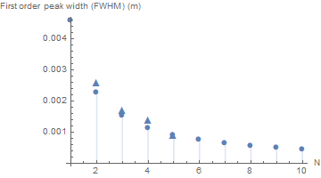

Figure 11

My observations were in close agreement with what was theoretically predicted, further validating the theory of multiple slit wave interference.

The Airy Disc:

In the final portion of the experiment, I observed the Airy disc using a circular aperture for the laser beam. The aperture-screen distance was $1.10±0.03cm$ and the aperture diameter was $b=0.2mm$. This aperture produced a set of dark rings around a bright center spot at the end of the apparatus opposite to the laser. I measured the radius of the innermost dark ring to be $r_{1}=0.38±0.08cm$.

Based on this measurement, I calculated the angle from the laser to the innermost radius to be $\frac{r_{1}}{L}=0.0035±0.0007 rad$. This was within experimental uncertainty of the theoretical value, $0.0040 rad$, given by the relation $\frac{1.22λ}{b}$. This confirmed both that the aperture was the one of 0.2mm diameter, not the one of 0.4mm diameter, and that the theory of diffraction held in the two-dimensional interference pattern I observed.

SUMMARY

I successfully measured the width of the laser beam at the light sensor while studying the diffractive behavior of light waves in this experiment. I also succeeded in investigating the double slit interference pattern, confirming the theory predicting the appearance and quantitative characteristics of the intensity response to position. I then was able to verify the diffraction of light through a single slit and check that this diffraction pattern served as an envelope for double and multiple slit interference patterns. Additionally, I was able to observe and measure aspects of the complicated interference patterns stemming from multiple slit diffraction. In my analysis of these patterns, I was able to validate all the predictions detailed by the theory. Finally, I observed and measured the Airy disc, one case of a two-dimensional interference pattern. In doing so, I was able to fulfill each of the objectives outlined in the introduction. A question for a future experiment could be how similar or different are the interference behaviors of mechanical water waves to the behavior I observed of light waves in this experiment.